**ACTIVITY-02**

**CONTRIBUTION TO ANY NATIONAL LEVEL INACTIVE OF GOVERNMENT OF INIDA AS SWACHH BHARATH**

**ACTIVITY DETAILS**

|  |  |  |
| --- | --- | --- |
| **Activity Head** | : | Contribution to any national level inactive of the Government of India as Swachh Bharat. |
| **Total Duration Spent** | : | 2 Weeks |
| **Activity Place** | : | Mysuru |

**ABSTRACT**

Swachh Bharat Challenge is an initiative to share your experiences of Swachh Bharat Abhiyan and invite other people to accept the challenge and join hands in the Abhiyan. Swachh Bharat Challenge is an initiative to share your experiences of Swachh Bharat Abhiyan and invite other people to accept the challenge and join hands in the Abhiyan.

Swachh Bharat Abhiyan is one of the most significant and popular to have taken place in India. Swachh Bharat Abhiyan translates to Clean India Mission. This drive was formulated to cover all the cities and towns of India to make them clean. This campaign was administered by the Indian government and was introduced by the Prime Minister, Narendra It was launched on 2nd October in order to honor Mahatma Gandhi’s vision of a Clean India.

The cleanliness campaign of Swachh Bharat Abhiyan was run on a national level and encompassed all the towns, rural and urban. It served as a great initiative in making people aware of the importance of cleanliness.

**Week-1**

**Day 1**

Online meeting with team members for discussion about our third AITCE activity. We discussed about various activity topics. Everyone came up with few ideas and topics. We wanted the topics to be relevant to current trends and these topics should be helpful. We did search using websites and referred few news headlines which were trending. Topics for first activity was chosen as Swachh Bharat abhinaya and Community Clean Up cleanliness drive.

**Day 2 and 3**

On day 2 of week 1 of first activity along with our group member we created a action plan how our event wanted to flow.

The action plan included the dates with the events along with time. This meeting was through online meeting. Event agenda was created. We also discussed how we can spread the meeting invitation. We came up with solution to make event e poster.

**Day 4 and 5**

Within this day all the ppt were ready, invitations were sent online through social media, messages. The meeting started on time; number people joined the meeting as excepted. We started with introduction and told why we are doing this activity. Each one us introduced. The ppt was presented and the talked regarding the slides. We covered all the contents in slide and showed the importance. We had Q and A session at the end. The feedback was also taken. We covered

* Introduction
* Background
* Objective of the emission
* Top 10 cleanliest cities
* Campaign
* Mission hit or miss
* Public participation importance
* Clean environment

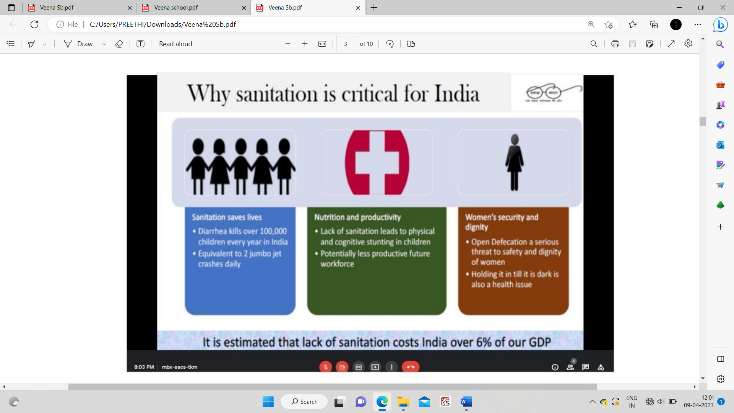

Fig: Online meeting on Swachh Bharath

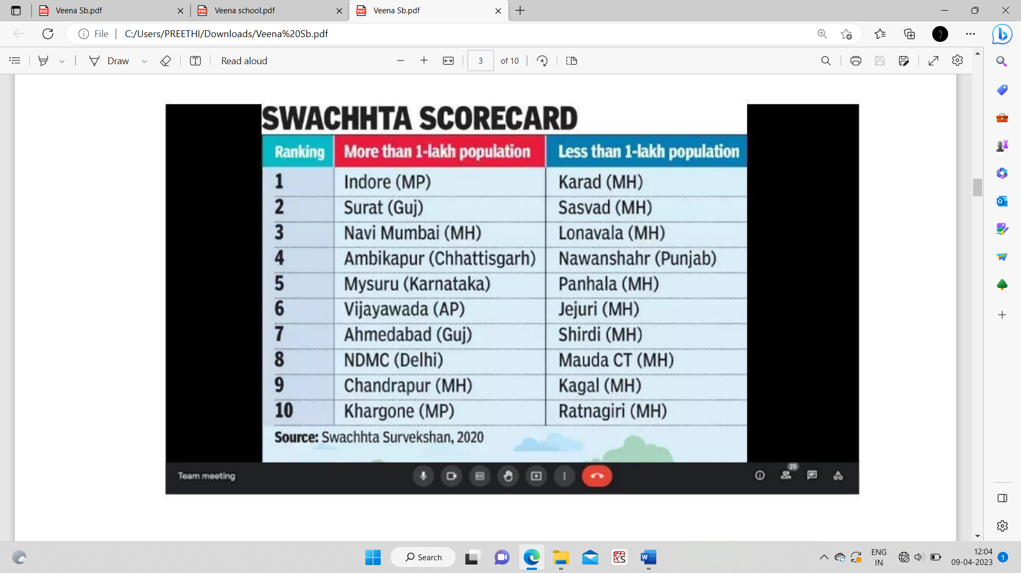

**Day 6 and 7**

On these two days we discussed and talk on Swachh Bharat Abhiyan for a clean and green India.

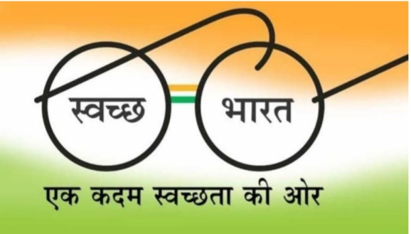

**Open defecation free**

Making India open defecation free was Swachh Bharat Abhiyan’s foremost and utmost goal. The initial idea was to provide a better environment and health to the Indian citizens. It has been a major problem of India for many generations which leads to diseases that can be avoided like cholera, diarrheal, and typhoid. The introduction and implementation of this mission have overall helped in developing the rural health of India.

**Improving sensitivity in urban landscapes**

Talking about urban areas the Swachh Bharat Mission helps to educate the people in urban areas when it comes to keeping the surroundings clean by not littering everywhere and using dustbins. This mission helped the urban dwellers to remember fundamental duties and rights together, and that cleanliness is not limited to government departments and is a duty of every responsible citizen of this country.

**Waterbody health**

The extreme need for Swachh Bharat Abhiyan was understood by the fact that big water bodies that are responsible for millions of lives like the river Ganga and Brahmaputra, were becoming the hub for waterborne diseases. These rivers are considered as holy, and taking a bath in these rivers were poisonous. However, the increasing amount of dirt and pollutants in these rivers was becoming hazardous for human health, especially around the surrounding areas. The mission helped to take notice of this and work towards cleaning these rivers, making it suitable for usable purposes.

**Children death rate**

The children’s death rate in India used to be very high and as per a report, at least a thousand children die due to lack of cleanliness and proper hygiene. This was an alarming reality of the nation which was taken care of with proper implementation of hygiene amenities and cleanliness measures in the rural areas along with proper education to the parents and guardians of these children who were at high risk before.

The Swachh Bharat Abhiyan is one of the biggest cleanliness movements across the world ever taken and has proven to be been India’s one of the biggest milestones ever. It has helped us as a nation both in the rural and urban landscape. Starting from clean streets and roads to developing infrastructure and achieving milestones like making India open defecation free. This movement was truly historic and there is no doubt that the **importance of Swachh Bharat Abhiyan** will be cherished for generations to come and looked back as a huge success for India.

**Week-2**

**Day 1 and 2**

We had Smt.Leela Shivakumar as guest who is the director of Clean Mysuru Foundation, Mysuru she spoke on the importance of cleaning and importance of doing at least 1 cleaning drive in our surrounding. Importance of reducing plastic and how to recycle. She shares her plan of keeping dry waste for a month and at the end of that month the collected dry water was given to a start-up company who collects plastic and recycle it to make benches, tables, and plastic.

**Day 3 and 4**

Cleanliness Drive at Mysuru city. i.e., Along with the people of MMC (Mysuru City Corporation) we cleaned 80 ft road at Mysuru.

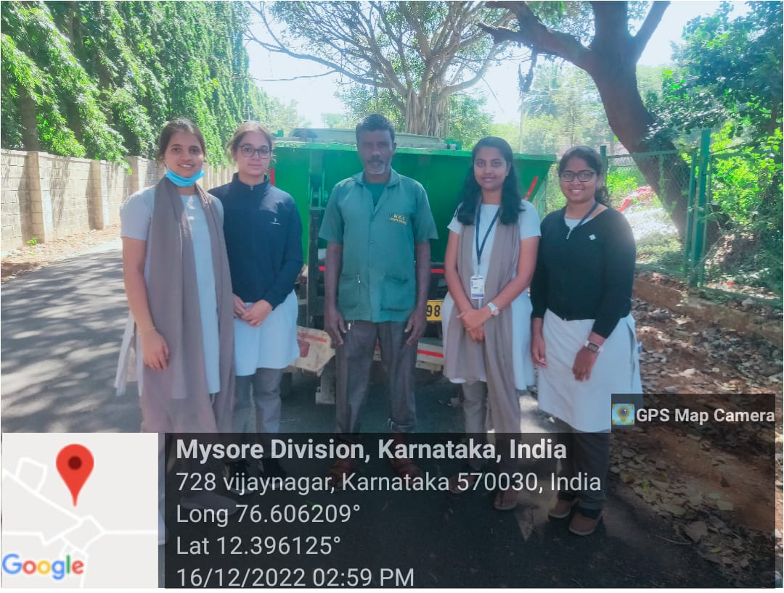

Fig: Cleanliness drive at Mysuru city

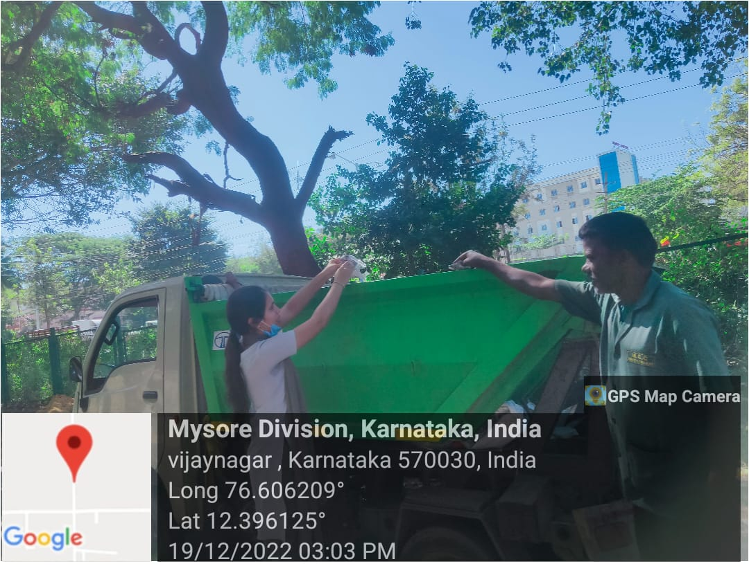

Fig: Cleaning along with MMC people

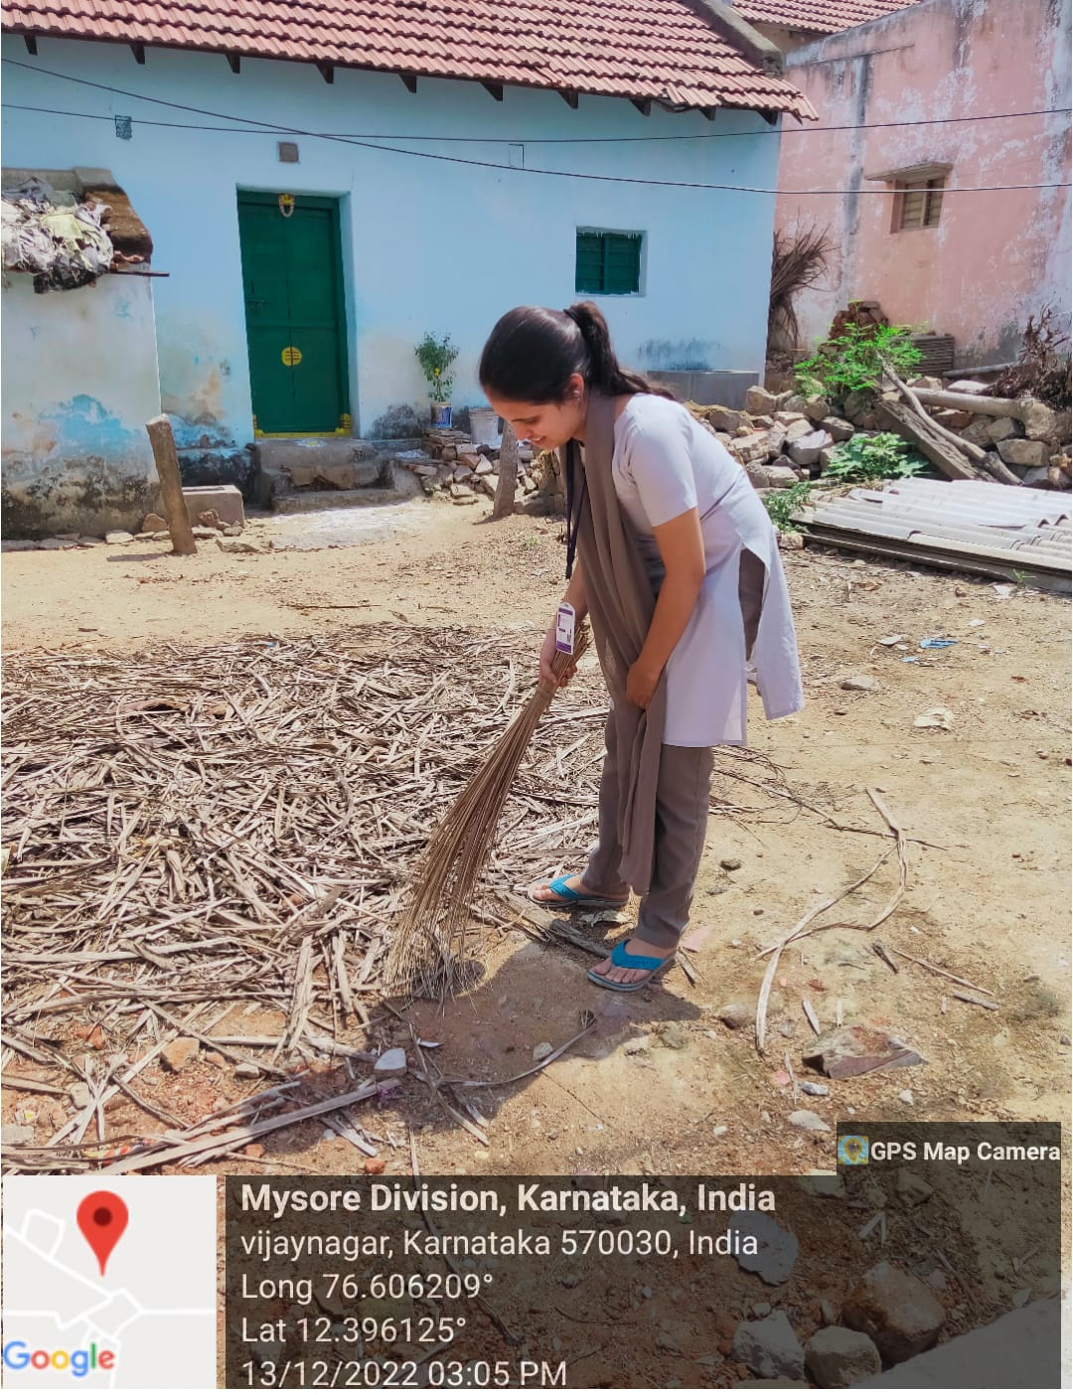

Fig: Cleaning my house surrounding

**Day 5**

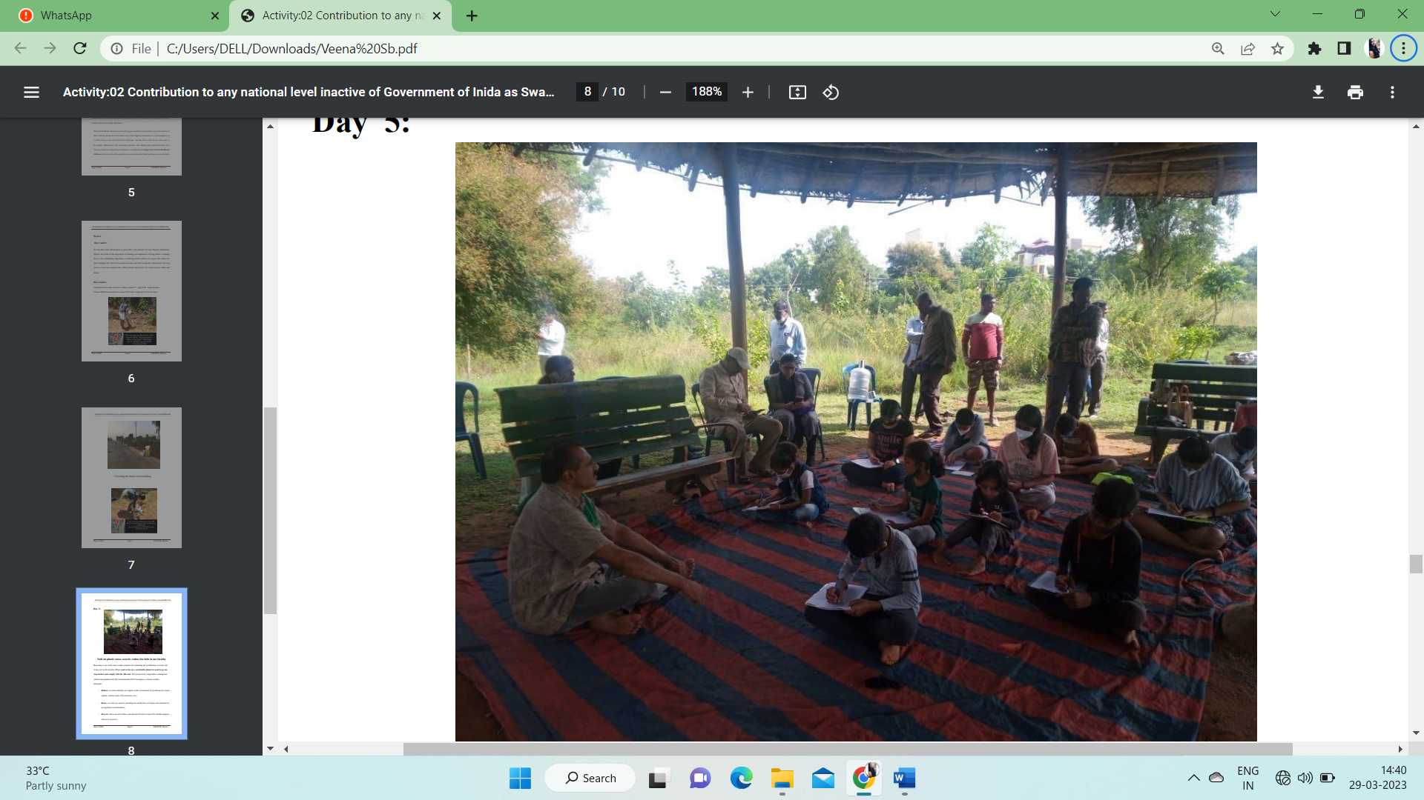

**Fig: Talk on plastic reuse, recycle, reduce for kids in our locality.**

Recycling is one of the most visible solutions for combating the proliferation of waste, but it does not work miracles. **If we want to live on a sustainable planet, we need to go one step further and comply with the 3Rs rule**. This proposal for responsible consumption, which was popularized by the environmental NGO Greenpeace, is based on three principles:

* **Reduce:** we must minimize our impact on the environment by producing less waste (plastic, nuclear waste, CO2 emissions, etc.)
* **Reuse:** we must get used to extending the useful lives of objects and materials by giving them a second chance.
* **Recycle:** when you cannot reduce your amount of waste or reuse it for another purpose, choose to recycle it.

We gave ides of using bottle to make toys and convert it into a pen stand. The children learn about the properties and possible applications of the materials, and develop their imagination and creativity by making puppets out of socks or houses out of shoe boxes.

**Day 6 and 7**

Along with the resource person Leela Sivakumar and the NSS volunteers gathered to clean the surroundings of the individual buildings in the campus. NSS volunteers enthusiastically collected plastic wastes, tea cups, weeds, and dry leaves spread over the surrounding areas. The volunteers gathered all the waste and trash bags to the place where the university arranged for the removal of collected wastes. The whole cleaning drive was quite inspiring and motivating for the NSS team members. Interacted with the localities and asked not to litter the place.

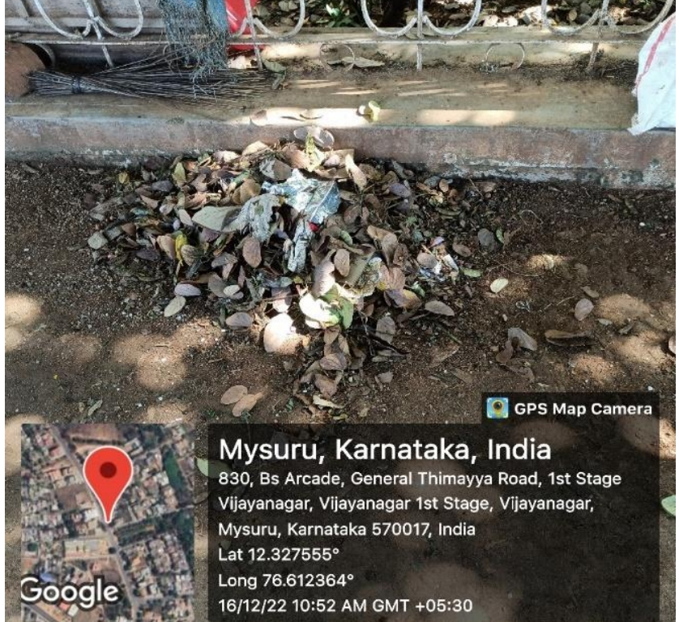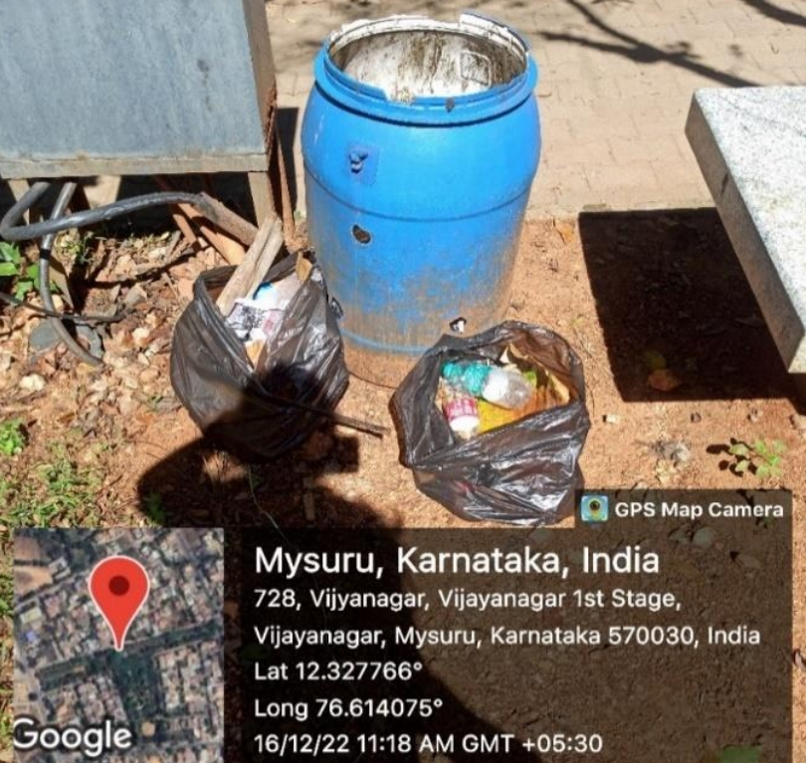

Fig: segregation of waste Fig : Segregation of dry and wet waste

**ACTIVITY EXPERIENCE**

* In this pandemic situation it was very important to spread awareness about Swachh Bharat to the people. Had a great opportunity to interact with various people and educate them and bring out awareness among them.
* We got more information about the mission initiated by our prime minister.
* We helped common people to understand the importance of the Swachh Bharat Mission, why this mission is important.
* Spent the valuable time in collecting, discussing about this mission.

**OUTCOME**

* Reduced usage of plastic bags which affects environment by toxic and marine animals.
* Created awareness among people and it was effective. Many started to use paper bags. Recycling the waste papers into paper bags.
* Helps in curbing environmental pollution.
* Empower rural women to learn new skills to create a paper bag from a discarded newspaper.
* Supported many individual or small group to be able to start a start-up to make various types of paper bags, with experience can grow the business to a larger scale.
* Save our ecosystem and biodiversity.